Redmond Stakeholder Interviews:
All-Inclusive Approaches to Affordable Housing

Introduction
One stakeholder describes affordable housing in Redmond as a “multi-faced beast.” On the surface, it is easy to comprehend the issue of affordable housing in Redmond as one of growing demand and little supply. The median household income in Redmond is at $39,000, yet the majority of the available housing stock are for single-family homes with price listings between $200,000 and $300,000. Redmond has a 60 percent and 40 percent split between single family and multi-family housing stock respectively, a trend that has held since 2010. Without many options for multifamily rental units, vacancy rates are currently less than one percent. As a the population continues to rapidly grow, so does the beast.
Another side of affordable housing in Redmond reveals a culture that stigmatizes affordable housing. This is characterized by a lack of collaboration between regional and local players, housing mix, and a lack of continual public involvement in the process of addressing the issue. Arguably, it may be easier to implement policies that only address housing stock, which are outlined in the city’s current Affordable Housing Plan (AHP) and included in other recommendations from our policy group. However, our stakeholder interviews revealed that housing stock in Redmond should be addressed side-by-side with efforts that increase public participation and collaboration. This would inevitably increase awareness of issues surrounding diversity, NIMBYism, homelessness, and providing stakeholders with better tools to make affordable housing comprehensive.
In particular, our group recommends that the city:

- Continue Efforts to Increase and Diversify Housing Stock through opportunities suggested by our fellow research team and our stakeholders. These policies focus increasing single-family options (cluster cottages, rowhouses, and et cetera) and multi-family housing in both rental and homeownership markets.
- Address Stigmas Against Affordable Housing by diversifying the housing mix and increasing public access and institutional knowledge. This creates meaningful dialogue with community members and staff at all levels of the affordable housing process.
- Move Towards Regional Solutions by acknowledging affordable housing as a regional crisis where problems and solutions are inextricably linked. Partnerships, workgroups, committees that address housing issues regionally will help Redmond approach affordable housing holistically.
- Increase Public Participation by employing a variety of strategies that engage and empower future and current residents, especially those that may have been left out of the process in the past, such as low income or marginalized groups. It is also essential to include developers and affordable housing providers as part of this process.
- Build Collaboration with stakeholders, government officials, and surrounding communities. The stakeholder interviews conducted during this project underscored a continual need for partnerships.

Background
In the last fifteen years, Redmond, Oregon has experienced a dramatic population increase, growing from approximately 13,000 people in 2000 to over 26,000 in 2013. This new population is largely a result of regional in-migration; over 90 percent of these new households came from outside the city (Reid, 2012). Additionally, projections expect to see the population increase to 40,000 people over the next twenty years (EcoNorthwest, 2005; PSU, 2015). However, Redmond is currently facing a shortage of affordable housing for their growing population. In fact, a 2003 study by the city found that over 30 percent of all households were cost-burdened, meaning that they spend over a third of their income on housing. In response to this growing housing need, Redmond drafted an Affordable Housing Plan (AHP) in 2007, seeking to identify barriers to affordable housing and ways to incentivize new development. This plan listed four objectives as part of their goal to provide more affordable housing:
1. The creation and preservation of affordable rental options;
2. The promotion of affordable homeownership opportunities;
3. The promotion of development of senior housing; and
4. Supporting regional affordable housing efforts.
The proposed strategies to achieve these objectives include land banking, providing incentives for developers, incentives for manufactured homes, first-time homebuyer programs, and zoning initiatives. Throughout the plan there is an emphasis on promoting homeownership within the community and providing incentives to private developers.
While Redmond’s AHP is comprehensive and fairly detailed, we believe that it is now out of date and in need of revision, especially considering that it was drafted before the housing market crash and resulting recession from 2008 to 2010. Furthermore, the current AHP suffers from having been drafted before a detailed housing study that the city contracted from Johnson Reid in 2013. This detailed report analyzed the demographic and housing makeup of Redmond, including information on demographics, income, growth projections, and public housing considerations. Key amongst these findings were the facts that:
- 20 percent of new population growth were Hispanic households;
- Less than 20 percent of Redmond residents commute outside the city for work;
- Safety and affordability were important considerations when looking for a new home;
- There is a significant preference for homeownership amongst residents; and
- Residents expressed need for better property management, low-density development, improved city maintenance, and more options for seniors.
In analyzing Redmond, it is obvious that homeownership is at a historic low and the demand for units is very strong, especially for single-family units. However, amongst the new population in Redmond, demand for rental units is high, especially amongst Hispanic households. However, the current market is quite competitive and low-income renters are finding themselves competing with middle-income renters for rental units. This increased demand for housing has driven up the cost of rentals and homeownership, making them less affordable than in previous years. This trend reveals that the goals listed in Redmond’s AHP might address the needs of their pre-growth population, but fails to consider the needs to their new demographics.

Methodology
For this project, we conducted 13 interviews with local stakeholders in the Redmond Community (Table 1: Conducted Interviews Stakeholder List). The purpose of these interviews was to explore several themes surrounding affordable housing in Redmond. The stakeholders were representatives from varying sectors in the Central Oregon region — developers, non-profit employees, and city officials. Before the interviews began, Heather Richards, the Redmond Community Development Director, suggested ten stakeholders to interview; our team supplemented the other five. Two of the city’s contacts were not available for interviews. The stakeholder breakdown was:
- Five Developers
- Six Non-Profits
- Two Government Officials
Our interviews began on February 5th, 2016 and ended on March 9th, 2016. The interviews were held by either phone or e-mail.
We provided each stakeholder with nine general questions (Table 2: General & AHP-specific Interview Questions). With each stakeholder interview, we were conscious of tailoring our additional questions to suit their particular perspective. For example, a non-profit staff member may have a differing view of the incentives and barriers to Redmond’s affordable housing than a developer might, and so any follow-up questions differed for each stakeholder.

Ethical Standards
In conducting the interviews, we followed ethical standards regarding the transparent use of data and respectful treatment of individuals. We were forthright with each stakeholder about the nature of our interview and the project. We communicated how and why the data would be used in our final report, and emphasized its greater utility to the city of Redmond.
In order to be respectful of stakeholders’ busy schedules, we offered the choice of interviews conducted over the phone or via email. Most importantly, we were respectful of the fact that the stakeholders came from different contexts, careers, and motivations, thus creating a richer atmosphere for varied (and potentially contradicting) opinions. We treated all information that we received as valuable contributions to the overall picture of affordable housing in Redmond.
It is important to note that with only 13 total interviews, we did not have enough data to use statistics or extract generalizations from the responses. What we did have were 13 perspectives, to varying degrees of discordance, on what affordable housing in Redmond currently looks like, and what it should look like. In other words, what we had were themes.
With this in mind, we chose to present the data in aggregate. This serves two functions: to protect the anonymity of our stakeholders and their perspectives, as well as to emphasize the reality that with such a small sample size, we were not able to pull any true conclusive results.
No one stakeholder had the “right” story. Neither do we.

Results
Stakeholder interviews were conducted via email and phone communication over a four-week period beginning in February 2016. Overall, 13 stakeholders were interviewed, including two government officials, six non-profit organization presidents or executive directors, and five developers located in Redmond or Central Oregon. Although all respondents interviewed were given the same questions, some chose not to respond to questions or indicated that they did not want to answer. For the purpose of consistency, those responses were not included these results.
All interview responses have been aggregated and separated into two categories:
- Responses that identify barriers to affordable housing; and
- Responses that identify possible solutions.
Each category contains themes that emerged from general consensus about particular topics, which are listed below. Although most questions were open-ended to allow for individual input, some questions asked respondents for a direct ‘yes’ or ‘no’ answer (Figure 1).

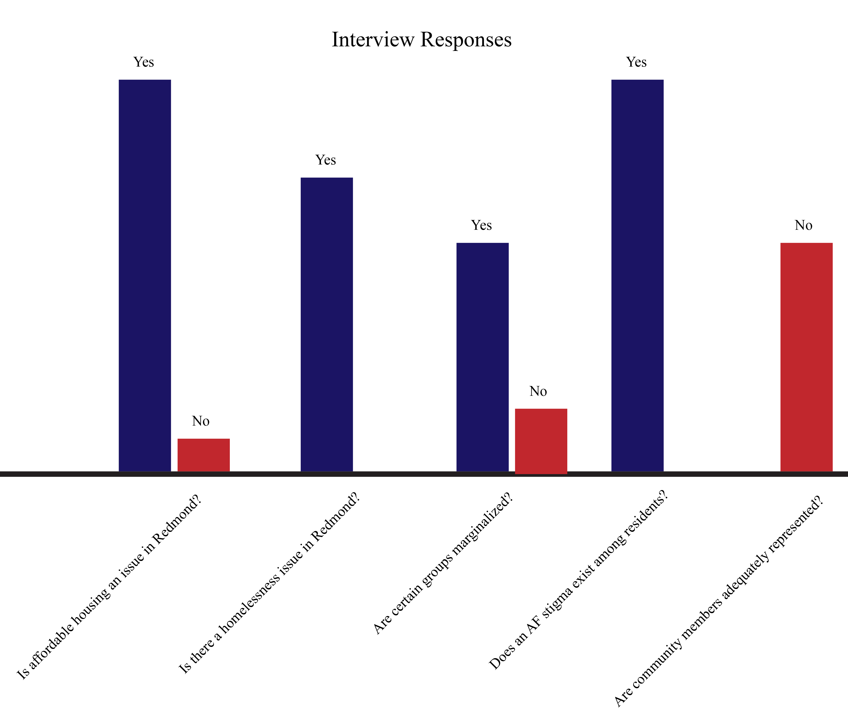
Figure 1

Barriers to Affordable Housing

Housing is Unaffordable
Nearly all stakeholders indicated that affordable housing was an issue in Redmond, recognizing housing issues that have already been identified by the city. National trends, such as inflationary housing, have caused a bust and boom cycle in the market and a possible soft rebound in housing values since the recession. Regional trends, such as population growth from in-migration, have squeezed the available market further, causing prices to climb even higher. Since much of the population experiences a low median household income, the available affordable options are alarmingly limited.

Affordable Housing is linked to Homelessness
Although our survey included a question about homelessness, many stakeholders brought up the issue before it was addressed. Homelessness in Redmond was often characterized by type, which includes BLM encampments, illegally parked RVs, youth that “couch surf”, families that live in their vehicles, and veterans. A few stakeholders noted that, although there are a few resources for homeless youth in Redmond, the number of homeless youth is surprisingly high when compared to regional and state trends. Hidden homeless was also mentioned as an idea that homelessness exists in Redmond without being publicly visible and without being openly addressed by the community.

Marginalized Classes
Ten stakeholders noted that there are certain groups of people in Redmond that are at risk of being marginalized or discriminated against in the housing market, but identifying which type of group varied widely between individuals. Two stakeholders did not think that Redmond had marginalized groups beyond the working poor, which is more a national trend and not necessarily endemic to Redmond. Groups that were mentioned included:
- The working poor, which are at risk for being evicted due to high rents charged by landlords in Central Oregon and suffer from predatory rate hikes.
- The Latino/Hispanic community, which make up a significant proportion of the population in Redmond.
- Youth, especially lesbian/gay/bisexual/transgender (LGBT) youth, who often have a higher likelihood of being homeless and are associated with mental health or drug-related issues, whether present or not.
- The mentally disabled, which are seen as a risk group by many landlords.
- The physically disabled, who often have difficulty finding ADA-housing.
- Veterans, who may or may not have issues related to physical or mental disabilities, are seen as a high-risk group by landlords.
- The elderly, who often live in low-income neighborhoods and may have difficulty keeping up with home repairs or modifications that accommodate the aging process.

Stigmas Thrive
Many stakeholders agreed that stigmas around the idea of affordable housing exist in Redmond. The stigmas are often more noticeable by community members when affordable housing projects are being proposed, but two stakeholders noted that stigmas might also be present within city government itself, which adds to the idea that affordable housing is somehow for lesser classes of society and does not add value to communities.

Possible Solutions to Increase and Improve Affordable Housing in Redmond

Incentives
Updating the development code, removing SDCs, and land pricing subsidies were mentioned as possible incentives that could create more affordable housing. Rolling back land supply and moving costs of infrastructure to the back end of the development process may also increase multifamily housing stock. Although the city was frequently credited as having great incentives that encourage downtown development, suggestions were made to apply the same programs to more rural and residential areas on the outskirts of town. While two stakeholders thought that inclusionary zoning would not incentivize affordable housing, several others thought it could create more opportunities.

Funding
Various stakeholders stated that gap financing, a construction excise tax, and a revolving loan or affordable housing fund were tools that could increase the amount of available funding in Redmond. One stakeholder noted that most funding options focus solely on rental housing, so having programs in place for homeowners, such as reducing mortgage payments, may be beneficial.

Collaboration & Public Participation
Many stakeholders had different ideas surrounding collaboration and public participation. Stakeholders thought that more collaboration with regional groups (developers, policy working groups, neighboring cities, community members) could advance efforts on the affordable housing front and garner more support (financial and administrative) for housing projects. The Portland Development Commission, the Homeless Leadership Commission, and Housing Works were given as examples of organizations that have developed strong regional partnerships. Stakeholders suggested that more needed to be done within city government to build regional partnerships, such as creating an Affordable Housing Committee separate from the existing Housing Committee or having more city representation in regional working groups in housing policy forums. One stakeholder thought that the city needed to be more proactive in creating partnerships and that the planning commission approach to affordable housing might be strengthened by looking at how other commissions are addressing the issue.
A number of stakeholders also thought that the city has done an inadequate job of encouraging public participation and public access to housing projects or programs. The way public processes are structured, such as having a public meeting in the afternoon, deters participation from community members that are most vulnerable to affordable housing issues. Some suggested that the city could improve efforts by changing meeting times to accommodate working families, provide daycare or transportation options to improve attendance, or increase public feedback by providing incentives for public comment or ways in which participation could happen outside of meeting halls (e.g. surveys located at public hotspots).
Increased public education/awareness was also advocated for, which could encourage participation, provide more access to affordable housing programs, and decrease stigmas. Stakeholders were concerned that the way in which housing information is presented, either in an affordable housing plan or a public meeting, prevents people of varying education levels from participation. Lack of advertising for housing events, programs, and tools was also a concern.

Discussion
Two theories that seem particularly useful to the conversation around housing affordability in Redmond are the Housing Continuum (Figure 2) and Housing Career. Both theories inform the discussion around how and why Redmond can best provide housing to those in need. The continuum reflects the variety of different types of housing need, while the housing career looks at the notion that people will generally move through the housing market in fairly predictable ways.
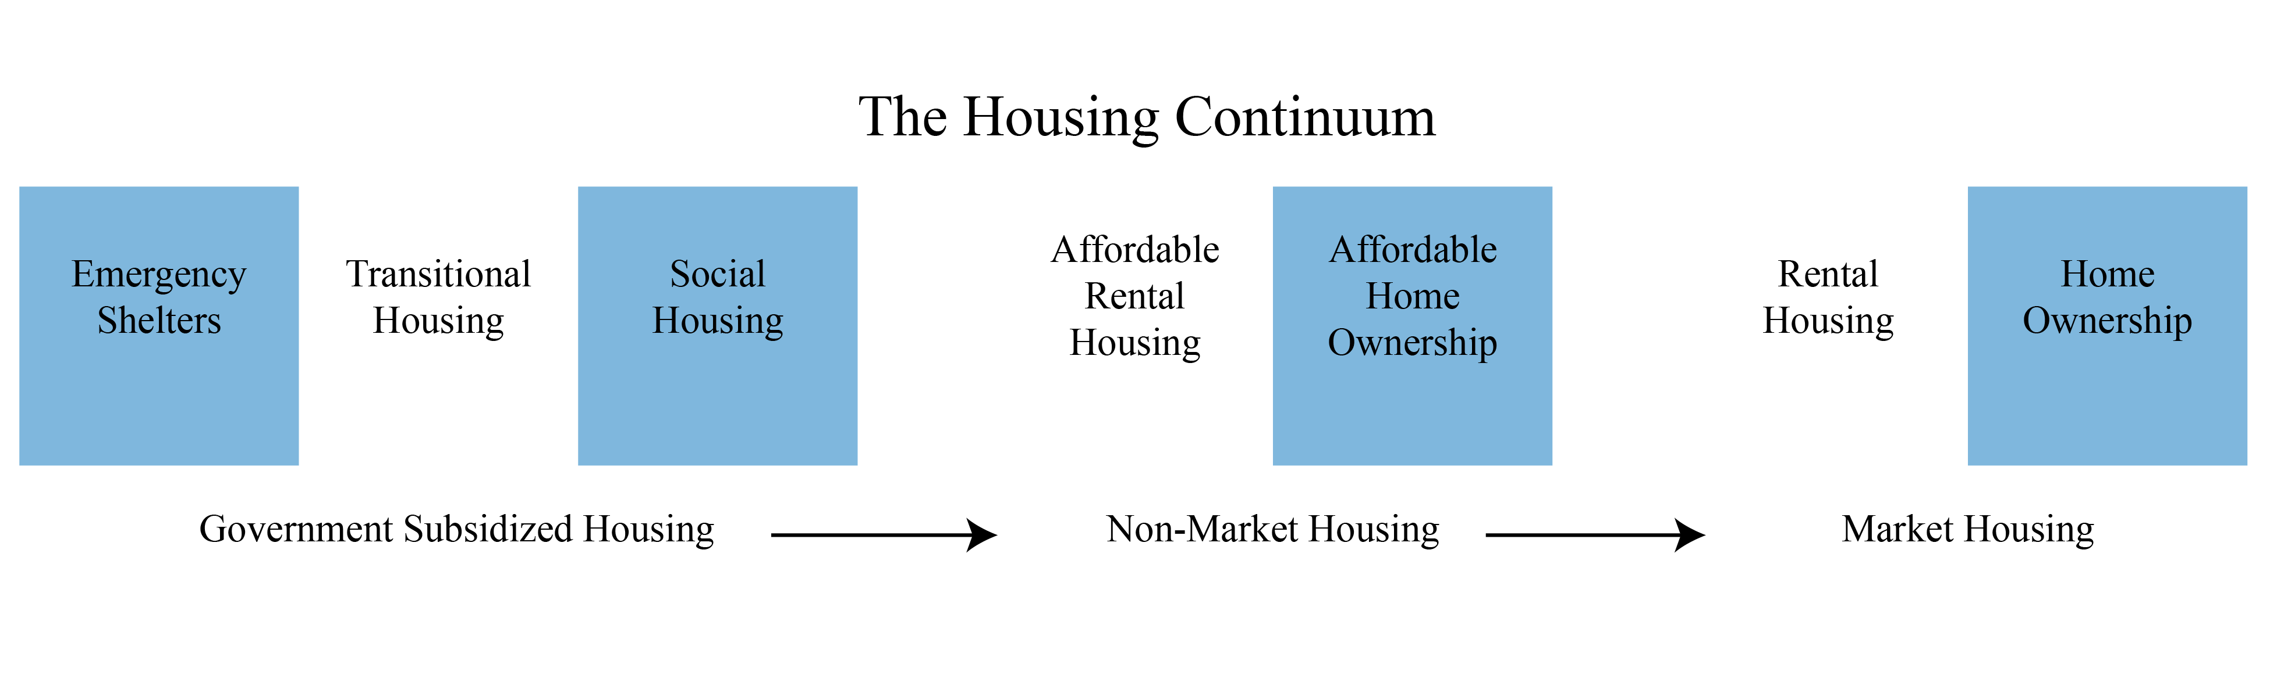
Figure 2

We heard from several stakeholders that homelessness is a problem in Redmond, and some stakeholders made clear that they saw it as a completely distinct thing from affordable housing. We also heard several comments about how Redmond also needs more high-end housing. Rather than seeing the former as being actually distinct from affordable housing - or the latter as a distraction - we see all of this as an expression of needs across the housing continuum. Redmond needs to take an integrative approach, including housing for people of all income levels, emergency housing for people in crisis, and transitional housing for those recovering from homelessness. These categories are all a part of the housing continuum. A critical part of theories around the housing continuum is that when any one section is missing or overwhelmed, then the neighboring regions of the continuum in both directions see additional pressure. In Redmond, which appears to have a deficit of low-income housing, the added pressures are seen on the low end of the rental market and in the number of people without housing at all.
Another theory that is valuable in combination with the housing continuum is that of the housing career, the notion that people tend to move through the housing market in predictable ways. The common idea is that people are raised in single-family homes, move into apartments, then into townhomes, back into single-family homes, and then retire into condos. However, most research indicates that this is not an accurate picture and that many people will express a favorite type of housing up front, often based in cultural expectations. In Redmond, the demand is greatest for single-family homes, which could provide a challenge to the suggestion that higher-density developments are the best way forward. Each person’s housing career choices are relatively unique and informed by a variety of factors. In planning for the future, Redmond would be well served to consider these theories around housing choice when revising and implementing their affordable housing plans.

Recommendations
In an effort to address key themes that came out of our stakeholder interviews, we have created five recommendations that are meant to be implemented through all stages and processes of updating the AHP. These recommendations are infused with the innovative tools discussed in our housing policy class to provide a more comprehensive approach to affordable housing policy. In general, we recommend that Redmond increase regional collaboration and public participation while also addressing stigmas against affordable housing.

1. Continue Efforts to Increase and Diversify Housing Stock
While our fellow research team will discuss policies that address housing stock in further detail, those we interviewed emphasized that Redmond has a shortage of homogeneous housing stock. Stakeholders also mentioned that the Redmond development code places constraints on developers and there is a high cost to developing affordable housing. For example, one of our interviewees remarked, “The vacancy rate is a bit higher [in Redmond] than Bend, but not by much. The lack of inventory is a problem.”
Almost every stakeholder we interviewed described the rental market in Redmond as difficult to break into and also detailed similar constraints to finding mutually beneficial solutions. Based on these remarks, we recommend that the City of Redmond implement policies to increase the amount and variety of housing stock available. Please refer to the research provided by our fellow team, which provides suggestions for improving and expanding housing stock.

2. Address Stigmas Against Affordable Housing
Many of those we interviewed stated that there was discrimination against certain marginalized groups and those who live in affordable housing units. Our recommendations for mitigating this are centered on education and outreach, housing mix, and collective action-based approaches to development code and affordable housing projects.

Housing Mix
Part of minimizing the stigma against affordable housing is to make it a more prominent and visible part of neighborhoods. Those who live in affordable housing are often “othered,” especially if they live in a more homogenous neighborhood. Additionally, affordable housing projects are oftentimes grouped together, which can lead to economic and/or racial segregation. This is known as concentrated poverty, which can lead to “diminished life chances for children and adults” (Bertumen, Levy, McDade 16). By using policies that encourage a mix of housing, Redmond can prevent or mitigate economic segregation. This can include the creation of mixed-income developments, increasing the types of housing permitted in a neighborhood, and including development code that does not prohibit or make it difficult to develop affordable housing developments.

Actions to Increase Public Awareness and Institutional Knowledge
We heard from several stakeholders that there was a need to educate decision makers, staff, the public, developers, and property owners about what affordable housing is and how to navigate the system. Although Redmond, the state, and the federal government have financial and institutional resources in place to help developers and property owners navigate the affordable housing system, it can be difficult to understand how to access these resources.
There is also a need for more education-based resources, such as training and workshops on affordable housing management and provision. For example, one of our stakeholders mentioned that discrimination against housing vouchers might be tied to the reality that many landlords don’t know or feel comfortable navigating the process of accepting vouchers. Providing training or resources for developers and property owners may remedy situations such as this, particularly for smaller developers and landlords.
Redmond could also make an effort to engage with homeowners and renters. If there is rental/homeownership assistance, the city should make this information easy to access.

Collective Problems Require Collective Action
It can be challenging for Oregon cities to approve affordable housing projects when there is significant local opposition or if residents misunderstand what affordable housing projects entail. While there are legitimate concerns that should be addressed, there are also concerns that may be used to block efforts at building and redeveloping affordable housing based on stigma and fear. To mitigate this, cities should educate decision-makers and staff about relevant local codes, state laws, and federal laws, such as the Federal Fair Housing Act. Essentially, decision makers and those involved in the land use process should understand that there must be very specific grounds for denying an affordable housing application.
Furthermore, Redmond may want to provide opportunities for developers and affordable housing providers to build relationships with staff and decision-makers, such as City Council and the Planning Commission. This may lead to more understanding about affordable housing as well as provide a pathway for decision-makers to build coalitions with those involved in affordable housing. Most importantly, it is important for decision-makers and staff to address genuine concerns and respond to falsehoods. For example, it is a common belief that affordable housing, particularly multifamily units, lowers property values. Yet, “virtually without exception, affordable housing developments have been found to have no negative effect on neighboring market rate property values, and in some instances have increased the value of neighboring property” (National Low Income Housing Coalition). For reference, we recommend using the 2012 National Low Income Housing Coalition (NLIHC) Advocates Resources Guide, which contains a list of property value studies based on statistical and empirical analysis and covers case studies from across the United States.
Another tool that cities can employ is developing a “zoning budget,” which uses collective map amendments to demonstrate how projected housing need is fairly distributed across neighborhoods. This also provides a clear diagram to decision-makers as to which neighborhoods are accepting infill and are being rezoned. This practice is further bolstered by usage of an enforcement mechanism, which provides entitlements for developers to build budgeted use until the citywide goal is met (i.e. property tax exemptions, inclusionary zoning, gap financing).
Zoning budgets may solve collective action problems because it is not focused on any particular neighborhood and demonstrates how housing will be allocated across all neighborhoods. This may make it easier for city councilors who are committed to a certain district to pass policy that they may not usually pass, as policy is typically passed on an individual basis without situating it in the context of larger efforts. This is also known as “issue bundling,” which is a strong tool for making general beneficial policies that have neighborhood specific costs. It also relieves the City Council of political pressure to “unbundle” zoning amendments and vote according to NIMBYism or “home voters” (owners of owner-occupied housing). When passing zoning amendments or new policies, it is important to include value capture for the neighborhood. This can include tools such as revenue from new constriction within the zone going towards funding community assets or reallocating SDCs to make needed improvements in the neighborhood.
Above all else, one of the best ways to address housing stigma is to have community conversations. For many, affordable housing is an intangible concept and there is a lack of understanding that those who live in affordable housing are part of the community in a variety of ways. To best begin this conversation, we recommend using the following resources:

3. Move Toward Regional Solutions
Many of our interviewees are regionally focused and consider Redmond as an individual market. The understanding of market dynamics in the region may make it easier to craft policies and incentives that would facilitate the development of new units in Redmond. To learn more about possible policies and incentives, please refer to the work of our fellow research team.
Central Oregon as a whole is stressed for housing. Rental vacancy rates are high and the market is still recovering from the recession, in which Central Oregon was hit particularly hard with foreclosures and an abrupt increase in population. 96% of those who moved to Central Oregon between 2008-2010 were from outside the area and foreclosure rates were between two to nine times more than the state average of 1.4%. Therefore, problems that are regional in scope should be addressed through regional solutions. Cities within the Central Oregon area, though acting as individual markets, are facing similar problems. While these problems are currently distinct, over time they will become more and more blurred.
Essentially, there is a present and future paradigm at play in Central Oregon. Even though these problems are isolated across cities, they will soon converge as land use patterns develop over time. Both Redmond and Bend are bordered by state and federal land. Although this won’t happen for a number of decades, at one point the two will become physically constrained by these natural borders. While Redmond has plenty of land to work with at this time, Bend and other cities are already struggling to expand. Thus, Redmond may be one of the few cities in Central Oregon that can actually accommodate population growth over time.
Approaching solutions regionally requires cities to frame interdependencies, while also addressing their unique differences. This also allows for housing providers and developers to address the market from a more holistic perspective, as opposed to a more piecemeal approach. We recommend that the City of Redmond begin crafting regional partnerships and committees that can address these issues from a regional scale.

4. Increase Public Participation
As Redmond continues the planning process around affordable housing, our team recommends that the City of Redmond put in significant work to include as many voices as possible. Oregon Statewide Planning Goal 1 states that citizen involvement requires a robust and widespread public participation process in all planning efforts. There are many benefits of public engagement that go beyond this legal requirement; indeed, those benefits are the reason Goal 1 exists. The 2007 AHP seems to have stumbled for a variety of reasons, but our team could not help but notice that only one of the stakeholders we spoke to described themselves as being involved in that process. Notably, most of these interviewees were provided to us by City staff prior to initiating our research. By including more people early on and keeping them involved, Redmond can help to ensure that the next plan achieves greater buy-in, better implementation, and more successful outcomes.
One of the most significant steps the city can take in this direction is to increase the degree of public participation surrounding the topic of affordable housing. Public participation can take many forms, ranging from purely informative to stakeholder empowering. The International Association for Public Participation (IAP2) provides a spectrum of approaches which includes goals, methods, and a “promise to the public” for each type of engagement. We suggest that the city employ more than one strategy as part of an overall plan to engage as many stakeholders as possible.
The main stakeholder populations that need to be involved are housing providers, developers, existing homeowners, and current or prospective tenants of low-income housing. Participation strategies for each of these groups should be specifically tailored to best meet the needs of both the city and the stakeholders. While we suggest collaborating with developers and housing providers, it is also important to involve the wider public, future and current residents of affordable housing in Redmond. In the case of current residents, substantial work can be done at the “inform” level to help reduce the stigma of new affordable housing and to highlight the need for such development. Future or representative residents can be engaged at the “consult” or “involve” level to help match new developments as closely as possible to the actual needs of the people who will be living there.
The University of Kansas provides a useful toolbox for how to increase participation, and a key recommendation is to consider who will benefit the most from being involved. This is a good starting point in deciding whom to bring into the conversation, more so than asking whose input is most important. In working with potential residents, it is vital that opportunities for consultation and involvement meet people where they are. There are a wide range of barriers that may make it difficult for people to participate. However, good process design can often help to overcome these barriers.
If using the format of public meetings or workshops, they should be designed around the schedules and needs of the people whom the city hopes to have in attendance. Scheduling meetings at times when working residents can make it - in places that are easily accessible - is an important first step. Including opportunities for youth involvement, making meetings friendly to families with small children, and including interpretation for ASL and spoken languages other than English can all be hugely beneficial in broadening participation. It is also necessary to conduct advertising and outreach in places that the people you hope will attend will be able to see and in ways that will actually engage their interest enough to find the time to make it.
Finally, it can be valuable to break from the standard public meeting format and engage people at a more informal or consultative level. Using focus groups and other tools designed to seek original input can produce beneficial results. Along these lines, it is important to provide opportunities for input beyond the primary method; if using meetings is the main tool, also include an online survey or meeting-in-a-box in order to broaden participation beyond just those people that your meeting design allowed to attend.
There are many reasons to increase public participation, and there are significant benefits to the city as well as to the stakeholder groups involved. Effective participation can help city staff to diagnose the actual needs of the public and various stakeholder groups, which will make developments more contextually appropriate. Involving partner organizations at the collaborative level can help to increase buy-in and help to sustain a plan over its lifetime. The relationships that city staff build as part of this effort can prove useful in their own right; it is easier to go back and ask questions of someone than to reach out and seek their input in the first place.

5. Build Collaboration
As part of an overall public participation effort, it is vital that the city invest time and energy into building collaborative relationships with key partners. This includes affordable housing providers, housing developers, and agencies at the federal, state, and local level. Where advisory groups already exist, involving them is vital; and where they do not, it can be valuable to create new ones. Specifically we recommend the creation of an Affordable Housing Advisory Committee to serve as a coordinating body for ongoing collaboration and advocacy between various stakeholders.
Crafting effective partnerships will be important going forward if Redmond is to effectively implement the next steps on making housing affordable. Since housing affordability is increasingly a regional problem, it is important to build solid working relationships with other cities and towns in the area, as well as the county and regional nonprofit housing providers. By building relationships with local actors in the affordable housing scene, Redmond is better positioned to provide useful incentives and to respond to opportunities as they arise. Coordinating with other municipalities can increase the likelihood of receiving state and federal funding, and can also help to share success stories and distribute some burdens.
The University of Kansas also provides a useful toolkit for building partnerships. They recommend determining who should be involved, bringing the group together, and building a shared mission. It is also critical to structure the group in such a way that resources and responsibilities are allocated in a way that works and sustains the mission of the partnership.
Redmond should pay particular attention to the relationship with Oregon Housing and Community Services (OHCS) as they provide the Low-Income Housing Tax Credit (LIHTC) to developers. Projects are scored based on how well the city addresses affordable housing, and Redmond currently does not meet many of their criteria. Working closer with OHCS could potentially result in more funding and could also provide valuable information and ideas for how to implement affordable housing strategies. OHCS recommends the creation of a new affordable housing plan and an Affordable Housing Advisory Committee to ensure that the plan is followed through on. In creating such a committee, it would be important for Redmond to determine what roles and responsibilities would be included, as well as whom the committee would be responsible to.

Conclusion
Our recommendations represent what Redmond’s future could look like. They attempt to tackle the multi-faced beast that is affordable housing. Focusing on providing necessary housing stock through developer incentives, funding mechanisms, and other programs are certainly needed, but it should be done through collaborative processes that encourage meaningful public participation and discussion. Other faces of affordable housing, such as homelessness or groups that have become marginalized in the housing system, should also be addressed during every stage of the process. We urge the city to consider these recommendations in any future endeavors with their housing policies and programs.

References
Clark, William A.V., Marinus C. Deurloo, and Frans M. Dieleman. "Housing Careers in the United States, 1968-93: Modelling the Sequencing of Housing States." Urban Studies 40.1 (2003): 143-60. Print.
ECONorthwest. (2005). City of Redmond urbanization study. Prepared for the City of Redmond. <http://www.redmond.or.us/home/showdocument?id=2658>
Hills, RM ; Schleicher, D. “Planning an Affordable City: Iowa Law Review, 2015 Nov, Vol.101(1), pp.91-136 [Peer Reviewed Journal]
International Association of Public Participation. "IAP2 Spectrum." N.p., n.d. Web. <http://iap2usa.org/resources/Documents/Core%20Values%20Awards/IAP2%20-%20Spectrum%20-%20stand%20alone%20document.pdf>.
Johnson Reed, LLC. City of Redmond, OR Summary of Phase I Findings: Market Trends and Analysis. Rep. N.p.: n.p., 2013. Web. <http://www.redmond.or.us/home/showdocument?id=3792>.
Johnson Reed, LLC. Redmond Housing Telephone Survey - Summary of Age-Weighted Results. Memorandum. N.p.: n.p., 2013. Web. <http://www.redmond.or.us/home/showdocument?id=1044>.
"NIMBYism: Overcoming Community Opposition to Affordable Housing." (2012): n. pag. National Low Income Housing Coalition. Web.
Portland State University Population Research Center [PSU]. 2015. Coordinated population forecast for Deschutes County: 2015-2065. <https://www.pdx.edu/prc/sites/www.pdx.edu.prc/files/Deschutes_Forecast_Report_201506.pdf.>
Regional District of Nanaimo. "Meeting Regional Housing Needs." Affordable Housing - Regional District of Nanaimo. Trinex Internet Solutions, n.d. Web. <http://www.rdn.bc.ca/cms.asp?wpID=2881>.
Ross, Jaimie. "NIMBYism: Overcoming Community Opposition to Affordable Housing." National Low Income Housing Coalition 2012: n. pag. Web. <http://www.flhousing.org/wp-content/uploads/2012/07/NIMBYism-Overcoming-Community-Opposition-to-Affordable-Housing.pdf>.
Work Group for Community Health and Development. "Creating and Maintaining Partnerships." Community Toolbox. University of Kansas, n.d. Web. <http://ctb.ku.edu/en/creating-and-maintaining-partnerships>.
United States. City of Redmond, Oregon. City of Redmond Affordable Housing Plan. By City of Redmond. Redmond, OR: City of Redmond, 2007. Print.

Table 1: Conducted Interviews Stakeholder List
Organization | Title | Org Type
Renaissance  Development | President CEO | Developer
Commonwealth  Development | VP Development NW Region | Developer
Eagle Mountain  Construction | President | Developer
Pacific Crest  Affordable Housing | Principal | Developer
Central Oregon  Builders Association | Senior Vice President, Government Affairs | Non-Profit/Developer
Housing Works | Executive Director | Non-Profit
Habitat for Humanity | Director | Non-Profit
J Bar J Youth Services | Executive Director | Non-Profit
Heart of Oregon Corps/YouthBuild | Executive Director | Non-Profit
St. Vincent de Paul | Director of Social Services | Non-Profit
Central Oregon Veterans’ Outreach | SSVF Program Manager | Non-Profit
Department of Land Conservation and Development | Regional Representative | Government
Oregon Housing and Community Services | Public Affairs | Government

Table 2: General & AHP-specific Interview Questions
Questions | Themes
Do you think affordable housing is an issue? | Redmond Context
Are there recent socioeconomic trends in Redmond and Central Oregon that affect affordable housing supply and demand? | Redmond Context
Is homelessness an issue in Redmond? | Redmond Context
Can you think of any success stories in Central Oregon or Redmond that have improved housing affordability in the last five years? | Redmond Context
What type of tools or programs might reduce barriers to affordable housing in Redmond? | Incentives & Barriers
What are the top barriers to providing affordable housing in Redmond? | Incentives & Barriers
Certain groups are often at risk for being marginalized or discriminated against in the housing market (i.e. low income, people with disabilities, seniors, latinos/hispanics, etc.). Are the affordable housing needs for these groups being met? | Inclusion & Diversity
Do you think there is a stigma against affordable housing among residents of Redmond? | Inclusion & Diversity
In your opinion, do you think community members are adequately represented during public participation processes that focus on affordable housing? | Community Needs
Does the current Affordable Housing Plan adequately address affordable housing needs? | Communication of the AHP
Does the current Affordable Housing Plan adequately communicate its goals and visions to staff, developers, and the public? | Communication of the AHP

